Rajith Radhakrishnan Midterm 1 10/27/16

1,2,3

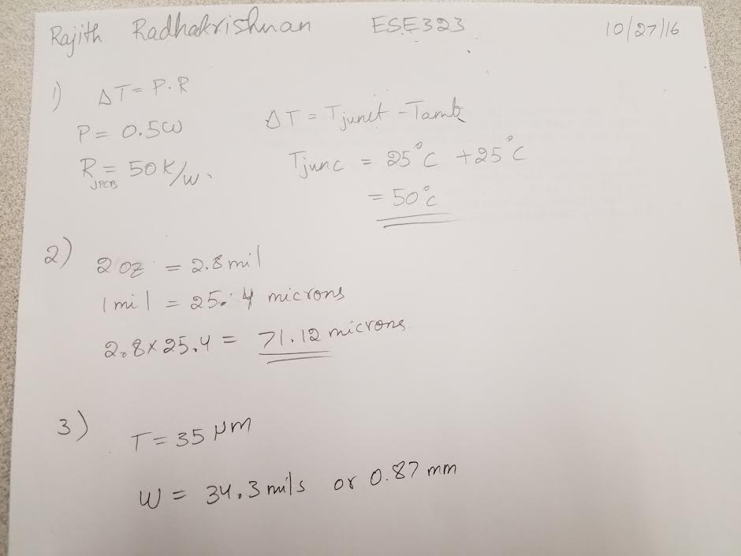

4.

5.Schematic design

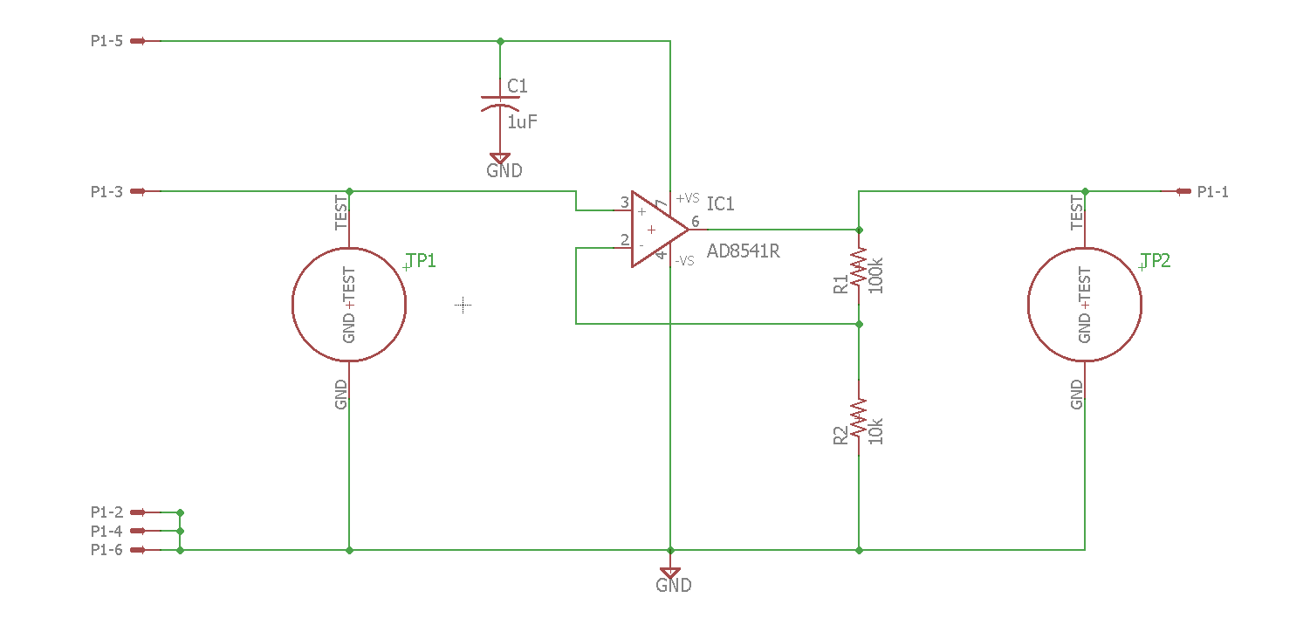

Board design

